**Name:- Yash Raj**

**Roll Number:- 24k-0737**

**Task#1:- Creating and Formatting a Table in MS Word**

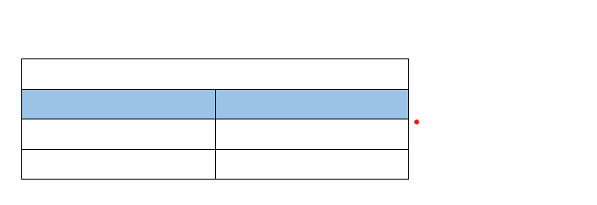

**Task#2:-** **Applying Borders and Page Layout**

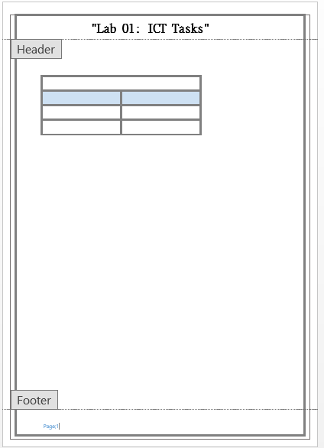

**Task#3:-** **Inserting Symbols and Equations in MS Word**

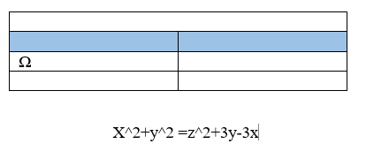

**Task#4:- Inserting Images and Shapes**

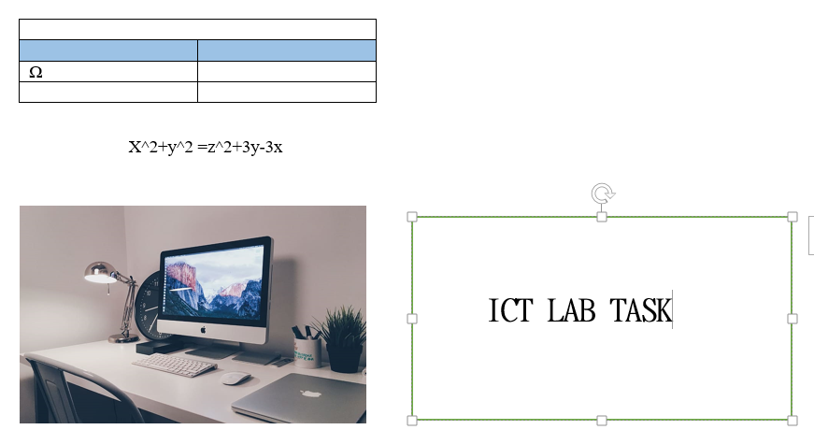

**Task#5:-** **Insert Bullet Points**

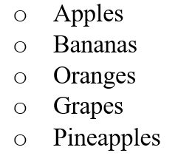

**Task#6:-** **Introduction to Formulas in MS Excel**

**Step#1:SUM**

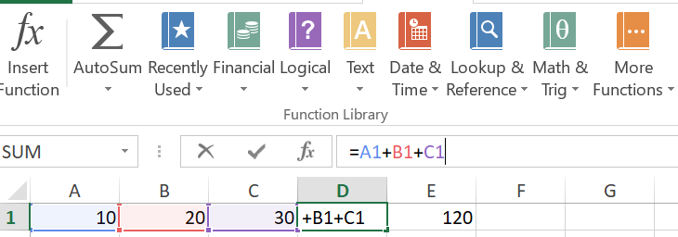

**Step#2:- Sum multiply by 2**

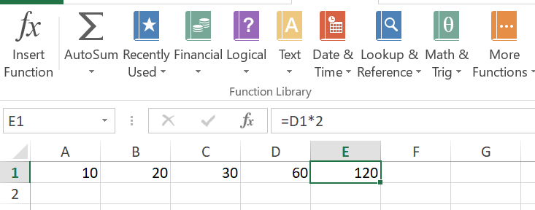

**Task#7:-** **Creating Functions in MS Excel**

**Part#1: Sum**

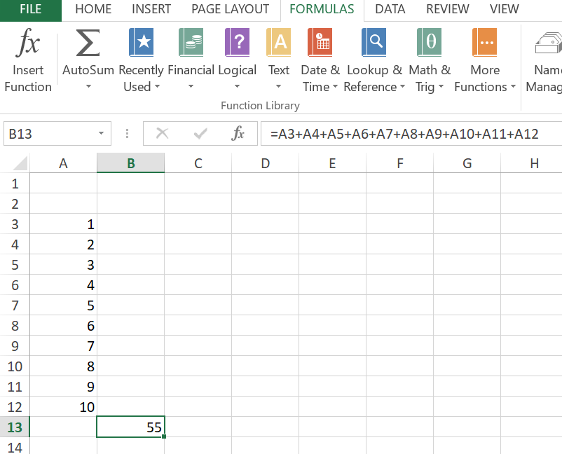

**Part#2: Average**

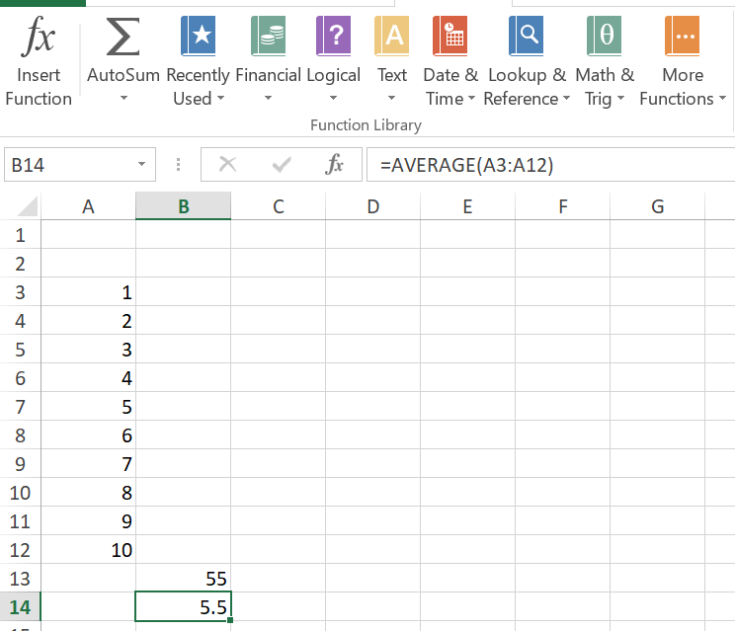

**Part#3: Max**

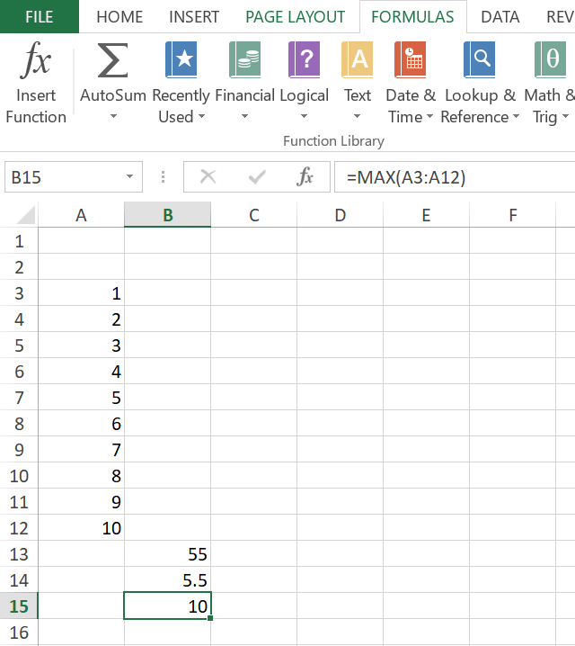

**Part#4: Min**

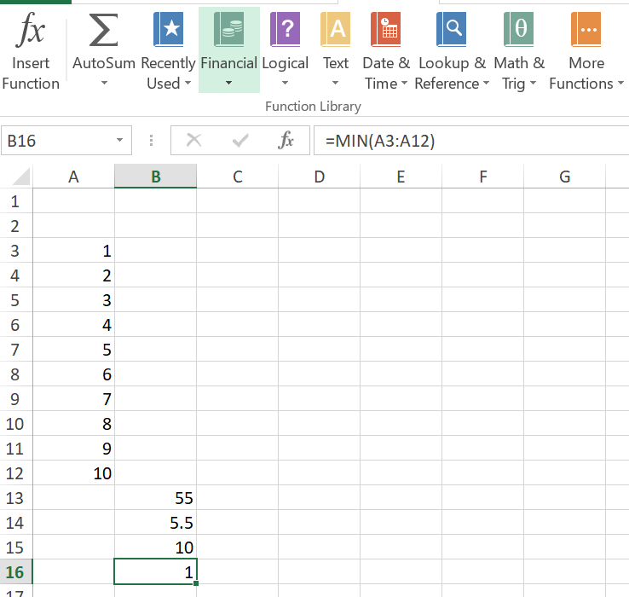

**Task#8:-** **Logical Functions in MS Excel**

**Part#1:**

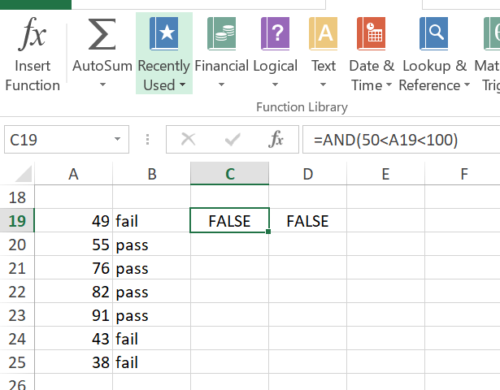

**Part#2:**

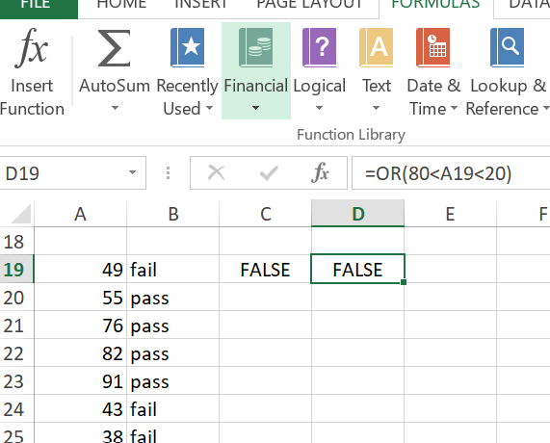

**Task#9:-** **Create a Simple Bar Chart in Excel**

